**Head of Obesity Action Scotland**

**Job Description – July 25**

**Section 1 - Description**

**Job Title: Head of Obesity Action Scotland**

**Grade: Grade 7 - Salary from £56,980 FTE – 35 hours per week**

**Location: Royal College of Physicians and Surgeons of Glasgow (hybrid working)**

Hybrid working enables employees to work both in the College and remotely. As part of this arrangement, employees will be required to spend at least 50% of their working time in the College, with the days being subject to the needs of the unit team, alliances and partnerships, and College management.

**We promote an agile, flexible workforce and while this is a full‐time post, applications from individuals seeking less than full time**, **job‐share, or flexible working arrangements are welcome.**

**Section 2 - Job Purpose**

To lead a health-focussed unit and convene an alliance hosted in a Medical Royal College that aims to change the way Scotland tackles obesity prevention and healthy food policy.

To challenge the understanding of a healthy diet, obesity (and what a healthy weight looks like) and associated risks with key groups, decision makers and individuals in public policy, media, health and beyond.

To identify and challenge the public and private sector interests that directly shape the obesogenic environment to identify and influence action required.

To shape the political and policy agenda through direct engagement with senior decision-takers to enable the change needed to deliver population health measures.

To convene and facilitate the Scottish Obesity Alliance, working with its membership to influence policy on overweight and obesity.

To develop and inspire a successful, engaged team that can deliver agreed aspirations, influence networks and alliances effectively.

In conjunction with and as directed by the Steering Group, to lead, develop and monitor programmes of work, overseeing delivery and ensuring that programmes are evidence-based, outcome-focussed, fully aligned with strategic priorities, seeking to promote a healthy diet and thus change the prevalence and profile of overweight and obesity in Scotland.

**Section 3 - Organisation Chart (Spring ’25)**

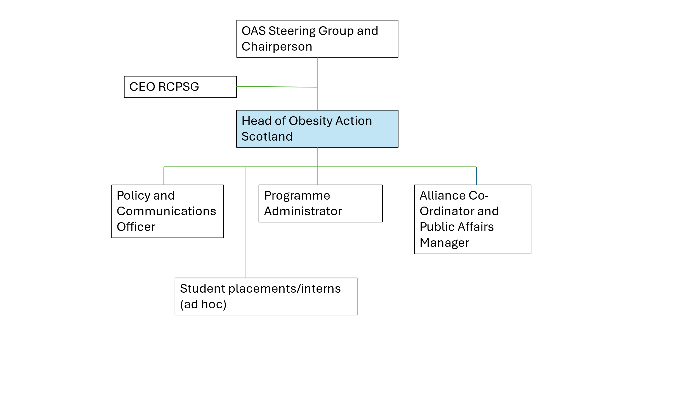

**Section 4 - Main Responsibilities and Role**

* Shape and lead an effective, high-profile discourse on obesity prevention, the food environment, nutrition, diet and healthy weight policy at a national level, demonstrating leadership, impact and exercising judgement with substantial autonomy;
* Engage with and influence key senior decision makers across political and public sector;
* Develop and maintain a respected external profile for the organisation through a programme of public affairs and high-quality communications;
* Be the “face” and “voice” of the organisation undertaking regular media work and political engagement;
* Identify opportunities to build the momentum for action on obesity prevention, the food environment, nutrition, diet and healthy weight policy;
* Develop and maintain effective working relationships in the public, political and third sector across Scotland, including new and existing alliances, coalitions and partnerships;
* Report to the Obesity Action Scotland Steering Group and enable the Steering Group to undertake its duties effectively;
* Manage the finances of the Unit, creating sustainable income sources. Report on income and expenditure in line with grant conditions to the CEO, Finance and Audit Committee of RCPSG and relevant grant making bodies;
* Manage and prioritise strategic work programme and operational aspects of the organisation and its staff;
* Maintain positive and constructive working relationships with all members of the staff team and ensure that all staff are kept up to date with relevant issues, ensuring their wellbeing and development;
* Maintain positive and constructive working relationships with RCPSG senior management team and seek opportunities for a one College approach;
* Undertake relevant professional development activities and training as agreed with line manager;
* Ensure that members of the staff team have access to the necessary professional development activities and training as required;
* Maintain confidentiality, as appropriate, with sensitive or privileged information, including day to day observance of data protection guidelines;
* Adhere to all internal and external policies, procedures and contribute constructively, as required, to their ongoing development;
* Have regard for your own personal health and safety and that of those around you.

**Section 5 - Core Competencies**

* **Knowledge generation and management:** gather, analyse and interpret evidence of the harm caused by poor diet and obesity and potential benefits of obesity prevention, effective population-wide interventions in the food environment, nutrition, diet and healthy weight ;
* **Knowledge**: understand the wider public health agenda in Scotland; understand the policy, political and civil society arena within Scotland as it affects the healthy weight environment;
* **Influencing:** influence policy makers, politicians, key decision makers and stakeholders as partners to implement effective healthy food, obesity prevention and related policies;
* **Communicating:** communicate our research, policy development and practice to a range of stakeholders including public audiences, making use of modern media channels;
* **Development:** develop tools and broaden alliances to build the will for change, change practice and behaviour, and monitor impact;
* **Learning:** share learning with relevant organisations, alliances and agencies;
* **Events:** influencesymposia, courses and events that highlight diet, nutrition and obesity issues.

**Section 6 – Knowledge, Experience and Skill Set Required**

*Essential*

* Educated to degree level or equivalent in a relevant discipline or subject;
* Successful leadership experience in a specific subject of public interest, influencing policy makers;
* Excellent networking, communication, problem-solving, influencing and stakeholder management skills;
* Understanding of the relationship between determinants of health, food and drink, nutrition and commercial factors;
* Excellent written communications and experience of report writing;
* Confident, strategic thinker and problem solver with the ability to shape priorities, analyse complex issues and offer a choice of solutions;
* Excellent organisational skills including highly developed time management skills, with the ability to prioritise effectively and manage a range of competing demands;
* Demonstrable experience of managing, motivating and leading a team, partnerships and alliances;
* Ability to operate at a strategic level, able to articulate the organisation’s and Alliance’s vision and direction as well as giving support at operational level to achieve objectives and outcomes;
* Ability to manage the interface between the external environment and internal operation, to gather critical intelligence and be accountable for outcomes;
* Ability to develop, manage and execute effective public affairs and communications strategies;
* Ability to undertake financial planning and identify and respond to income generating opportunities;
* Strong ethical sense in conducting relationships between stakeholders in the health sector and food industry;
* High level understanding of the use of research, evidence *and alliances* in shaping, influencing and developing policy and practice;
* Demonstrable experience in overseeing the development and delivery of programmes that influence policy, and communication strategies; relationship building and ability to articulate key messages and outcomes;
* Knowledge of how people learn and ability to design and facilitate dynamic learning opportunities;

*Desirable*

* Previous work in a public health field;
* Previous experience in food policy or nutrition related subject area;
* Previous work in engaging with alliances, media and communications;
* Awareness of human rights, equality and inclusion issues and stigma as they affect people who experience disadvantage;
* Knowledge of the healthy food, obesity prevention and health weight environment policy context in Scotland and awareness of the UK, European and international context;

**Section 7 - Terms of Employment**

As can be seen from the organisation chart in section 3, the postholder will report to the CEO of the Royal College of Physicians and Surgeons of Glasgow on the following matters – finance, people and corporate governance. The post-holder will report to the Obesity Action Scotland Steering Group on matters related to strategy, policy and programmes, agreeing and reviewing objectives with the Chair of the Steering Group; the Group will be made up of representatives from the Scottish Academy of Royal Medical Colleges, the NHS, policy and other subject matter experts.

There is a six-month probationary period for this post.

Obesity Action Scotland is co-located at the Royal College of Physicians and Surgeons of Glasgow. The postholder will be an employee of the Royal College of Physicians and Surgeons of Glasgow.